# KPMG-City (name to be changed)

KPMG-city is a game that will be designed for KPMG. The purpose of the game is to create a fun environment for KPMG’s personnel to learn compliance and risk management. Currently, these subjects are taught using online courses which the personnel see as boring an ineffective. With the game, the learning should be made fun and thus a lot more effective.

## Concept

In KPMG-City, the player controls a city-like neighborhood. At the beginning, the basic city is composed of a building for every training topic and a building that represents his office. These buildings will evolve/grow depending on his scores in that specific topic. Depending on your job grade, you can start with different kinds of building representing different topics according to the job grade.

The player comes into contact with several situations (mini-games) by entering a specific building; the mini games will teach and evaluate his compliance skills. Correctly completing these situations increases the player’s scores in the specific compliance topics.

By playing the game, the player will not just score points in the topics, but also earn in-game money which they can use to customize their appearance (e.g. suits), buildings, the neighborhood and their own virtual office. (by buying/adding environment elements, much like in the “Farmville” way)

In this virtual office, the player receives messages concerning new missions and events. Also in the office is a trophy case. By completing certain objectives the player can earn trophies like “Master of compliance” or “One test is enough”. This will stimulate the player to perform better in the game.

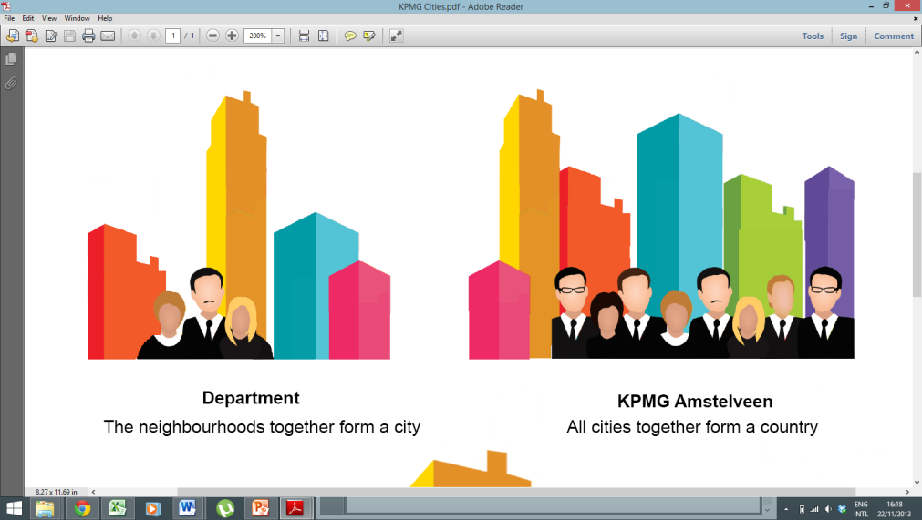The neighborhood the player moves and personalize is also part of a district within the city, which represents the department the player belongs to. The city on the other hand represents the whole office (e.g. KPMG Amstelveen) and which includes districts for every department in that office. On a world view, there is thus a city for every office within KPMG. This hierarchical score-structure will be developed to support competition and social pressure between players in a department, departments in an office and offices in KPMG.

Department represented as a District in the city.

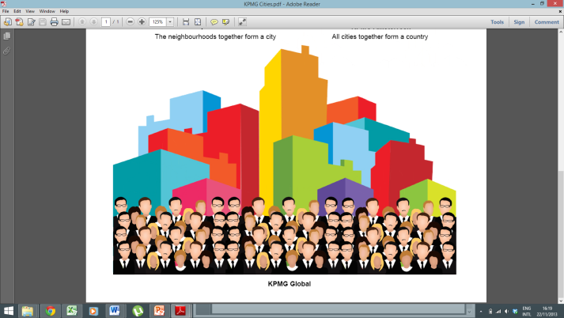Furthermore, the player will only be able to physically walk around its own neighborhood, but will still be able to see how other players are doing by consulting certain leader boards.

To support the several competitive elements, the cities and districts can be displayed on screens with the same buildings structure introduced before. Therefore, for example, a certain city will be displayed as a composition of different district (representing the various departments) each composed of one building for each topic relevant to that department; the height of the building representing a certain topic will be based on the scores of all the people from that department that have completed mini games in that specific topic. This will inform employees how their department (and their office) is doing compared to the others.

KPMG Amstelveen represented as a city.

## Engine

The idea is to have the main game world in an isometric environment. The player can walk in between buildings, enter them and visit different office floors. So the game engine should support this viewpoint. The minigames can vary from point-and-click to quiz type minigames to maybe even a full 3d environment (if necessary in a training).

Furthermore, access to the game should be easy for KPMG employees. The best way to provide this easy access is through the browser. This means that we will use a game engine that has either a web player or has to ability to convert the game to HTML5/JavaScript.

The current considerations of engines are:

* Unity (http://unity3d.com)  
  This engine might be overkill but it supports everything we are looking for. It also has a web player, which requires the installation of a browser extension. Unity gives the most control over the gameplay elements compared to the other engines.
* Isogenic Engine (http://www.isogenicengine.com)  
  This is a native isometric game engine which exports the game in HTML5/JavaScript. This makes it easy to use for players but some flexibility is lost because it only supports 2D minigames. TU Delft probably does not have a license for this engine so this must be purchased as well (well over €100).

Our preference is Unity because it gives more control and freedom that will be needed in developing the minigames. It is also a better choice when the game is going to be developed further after we delivered the prototype in January since Unity is a well-known engine. It shouldn’t be hard to find game studios that work with Unity. Unity does require an extensive amount of work because of the freedom we get. So this has to be taken into account in the game planning.

If there is a budget for the engine, we could also investigate the potential of Isogenic Engine. The native support for isometric views does save us a lot of work so it might be worth the investment as more time can be spent on the actual game itself instead of the visuals and objects in the game.

Note: An isometric view for a game is a top-down 2D representation of the world without depth or changing view angles (e.g. Farmville).

## Example: Isometric view

## 